Lab Exercise 20 - Deploying a Web Application using AWS ECR and ECS

Vishal Pandey
500125280

B2 DevOps

Objective
Learn how to containerize a web application, push the Docker image to Amazon Elastic Container Registry (ECR), and deploy it as a highly available service using Amazon Elastic Container Service (ECS) with AWS Fargate.

Prerequisites
- AWS Account with administrative privileges.
- AWS CLI installed and configured on your local machine.
- Docker installed and running.
- Basic understanding of Dockerfiles and HTML.

Step 1: Create the Web Application Files
First, prepare the source code and Dockerfile for your web application.
- Create a directory for your project (e.g., my-web-app) and navigate into it.
- Create an index.html file with the following content:
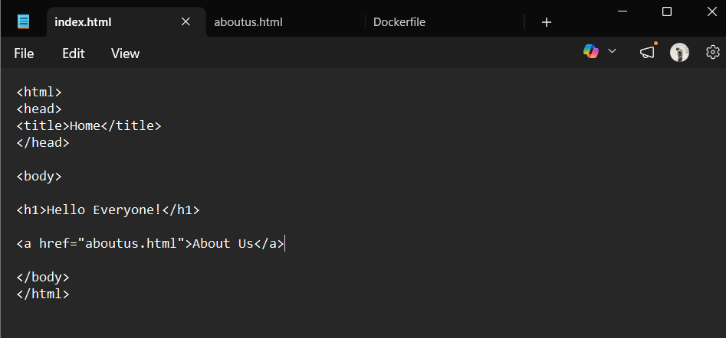
- Create an aboutus.html file with the following content:
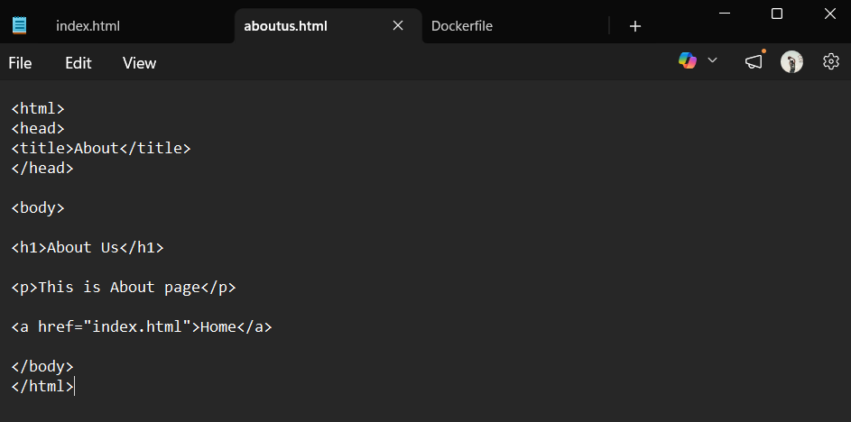
- Create a Dockerfile to serve the HTML files using the official Apache HTTP server image:
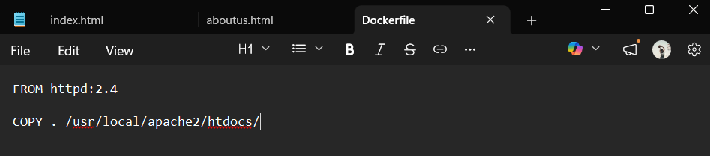

Step 2: Create an ECR Repository
Create a secure place in AWS to store your Docker images.
- Log in to the AWS Management Console and navigate to Amazon Elastic Container Registry (ECR).
- Click Create repository.
- Set the repository visibility to Private.
- Enter lab20 as the Repository name.
- Leave the remaining settings as default (e.g., Mutable tags, AES-256 encryption) and click Create repository.
- Once created, note down the URI of your new repository (e.g., 578673727059.dkr.ecr.ap-south-1.amazonaws.com/lab20).
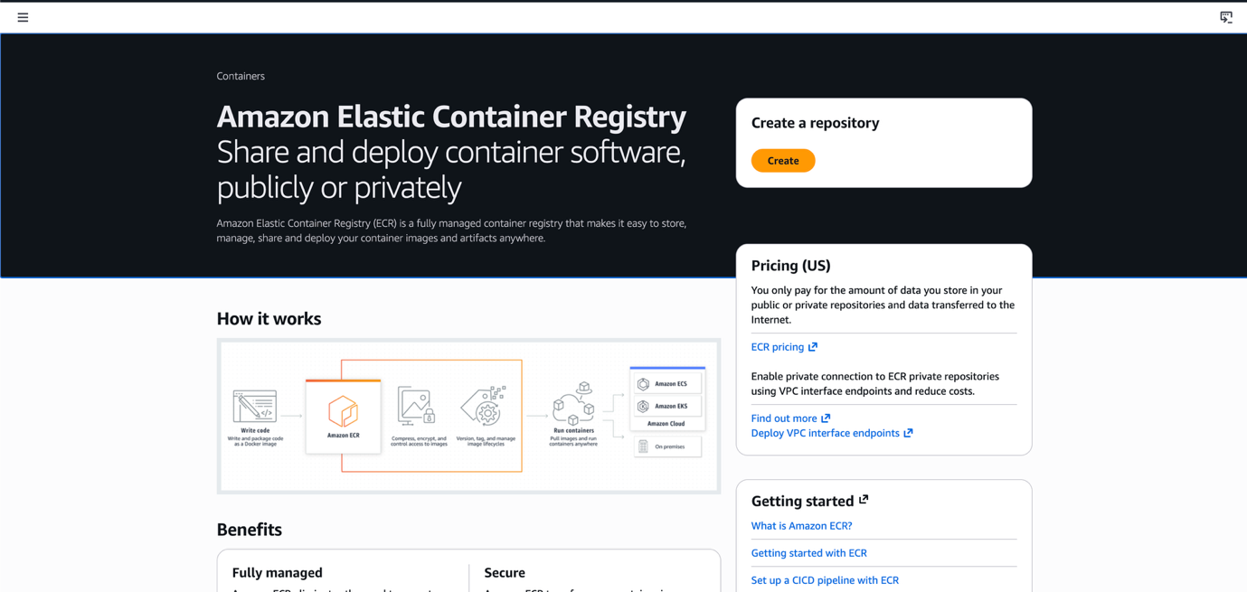
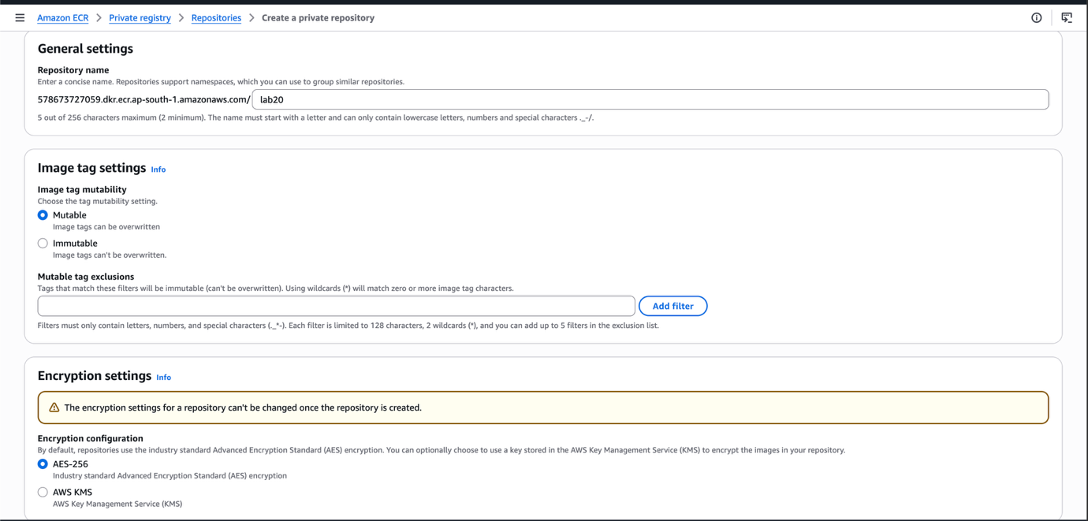
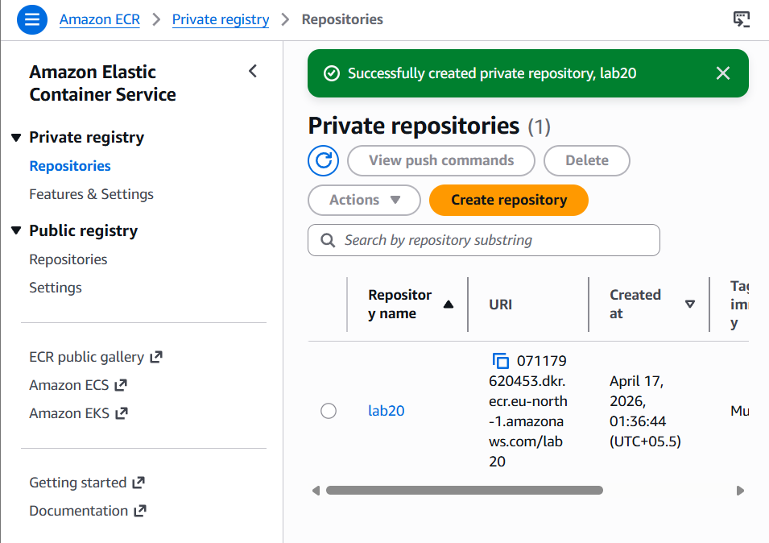

Step 3: Build and Push the Docker Image
Use your local terminal to build the image and push it to the ECR repository created in Step 2.
- Authenticate your local Docker client to your ECR registry. Replace the URI with your specific account details:
aws ecr get-login-password --region ap-south-1 | docker login --username AWS --password-stdin 578673727059.dkr.ecr.ap-south-1.amazonaws.com
Expected Output: Login Succeeded

- Build your Docker image locally:
docker build -t lab20 .

- Tag your local image to match your ECR repository URI:
docker tag lab20:latest 578673727059.dkr.ecr.ap-south-1.amazonaws.com/lab20:latest

- Push the tagged image to AWS ECR:
docker push 578673727059.dkr.ecr.ap-south-1.amazonaws.com/lab20:latest
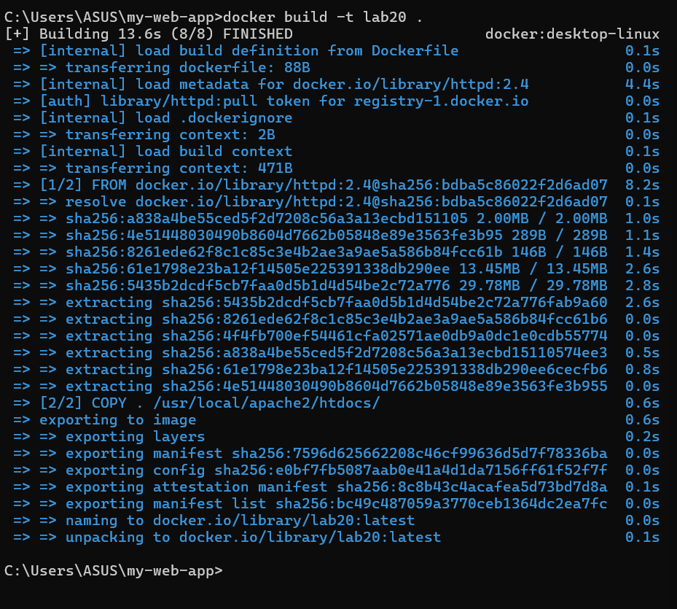

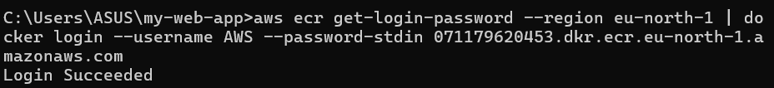
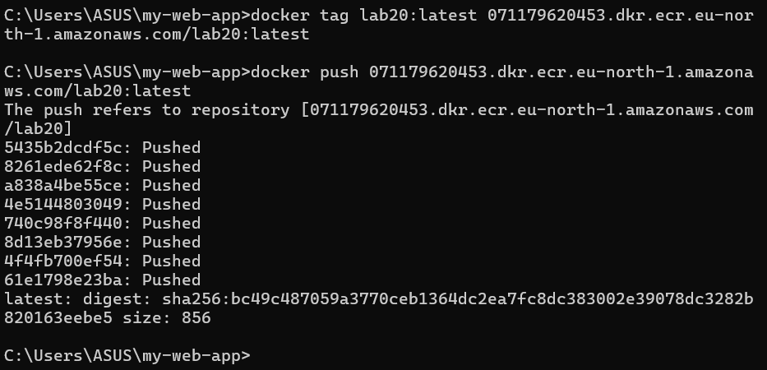

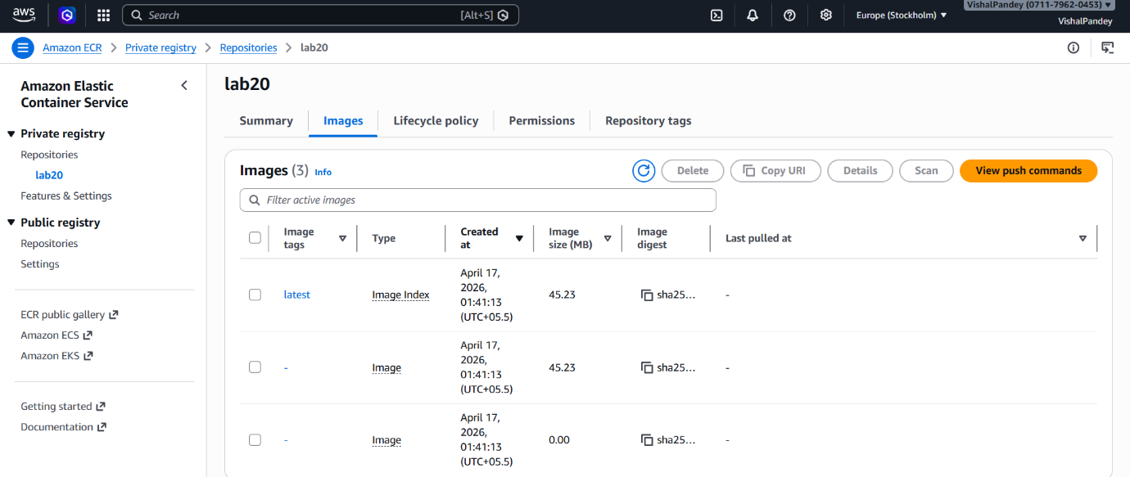

Step 4: Create an ECS Cluster
Set up the infrastructure to run your containers.
- Navigate to Amazon Elastic Container Service (ECS) in the AWS Console.
- Select Clusters from the left-hand menu and click Create cluster.
- Set the Cluster name to lab20.
- Under Infrastructure, select AWS Fargate (Serverless) to run containers without managing the underlying EC2 instances.
- Click Create.

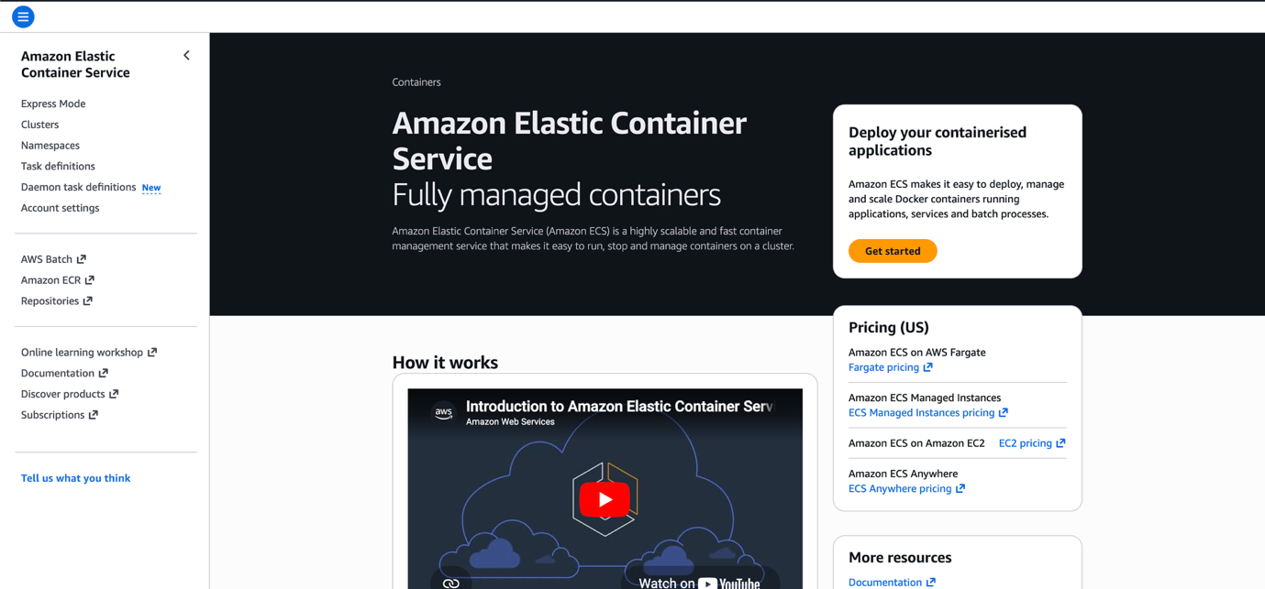
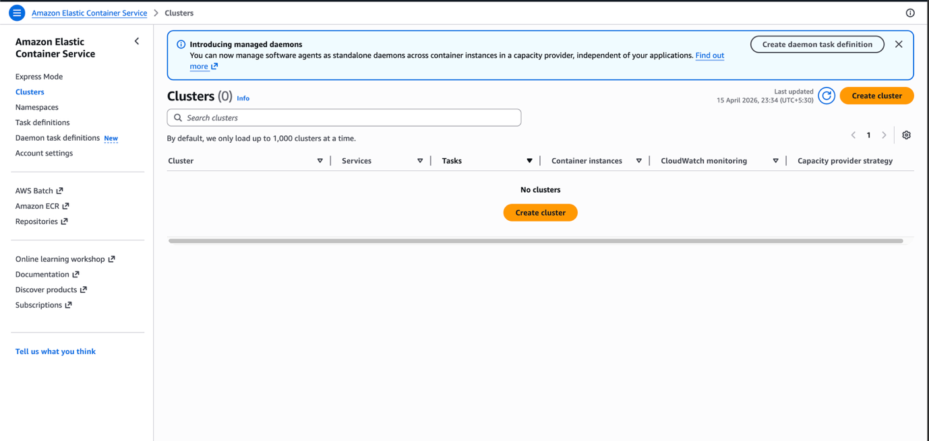

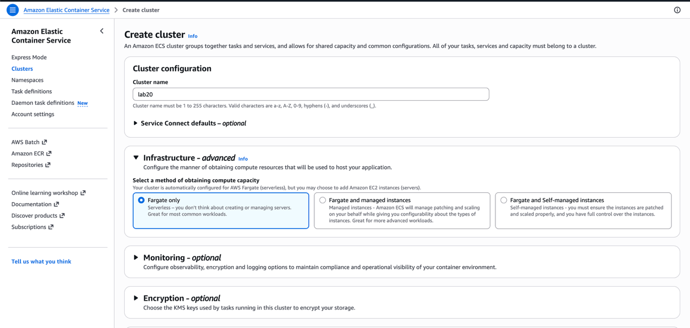
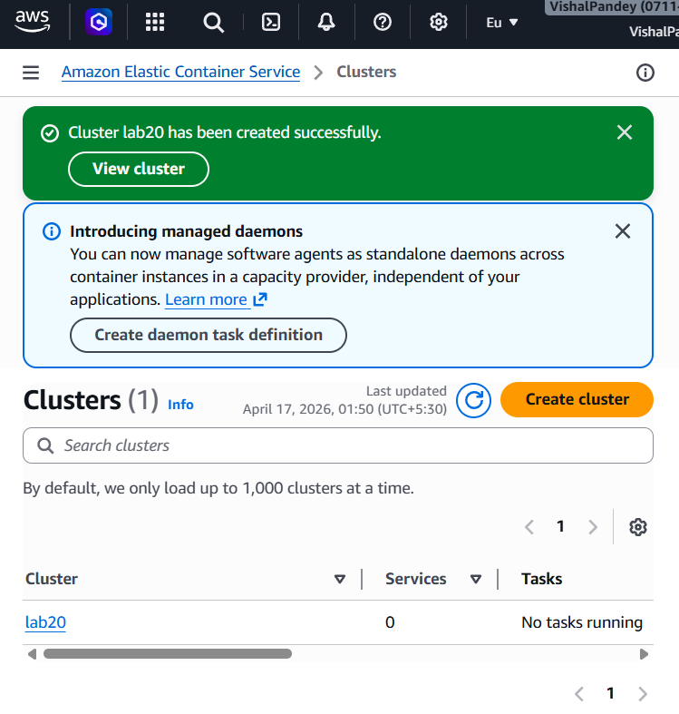

Step 5: Create a Task Definition
Define how your container should be configured when it runs.
- In ECS, select Task definitions from the left menu and click Create new task definition.
- Set the Task definition family name to lab20-task.
- Under Infrastructure requirements, select AWS Fargate as the launch type.
- Set the Operating system/Architecture to Linux/X86_64.
- Configure the Task size:
  - CPU: 1 vCPU
  - Memory: 3 GB
- Under Container - 1, configure the following:
  - Name: lab20-container
  - Image URI: Paste the URI of your ECR image (e.g., 578673727059.dkr.ecr.ap-south-1.amazonaws.com/lab20:latest).
  - Container port: 80
  - Protocol: TCP
- Click Create.
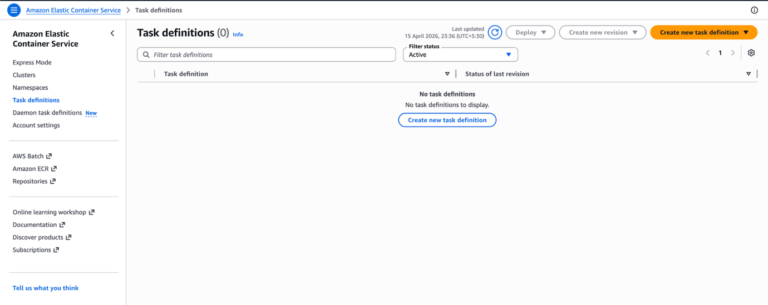
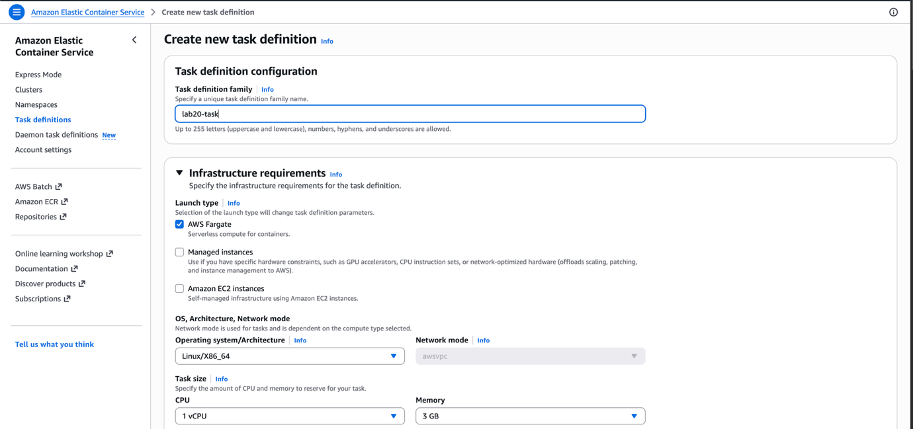
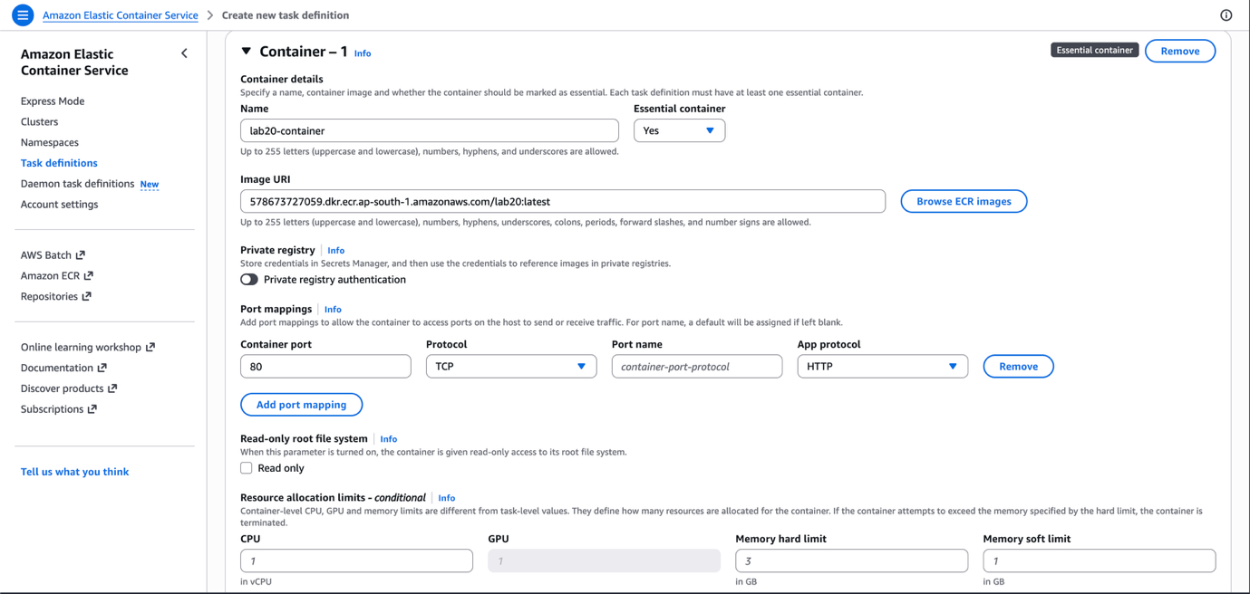
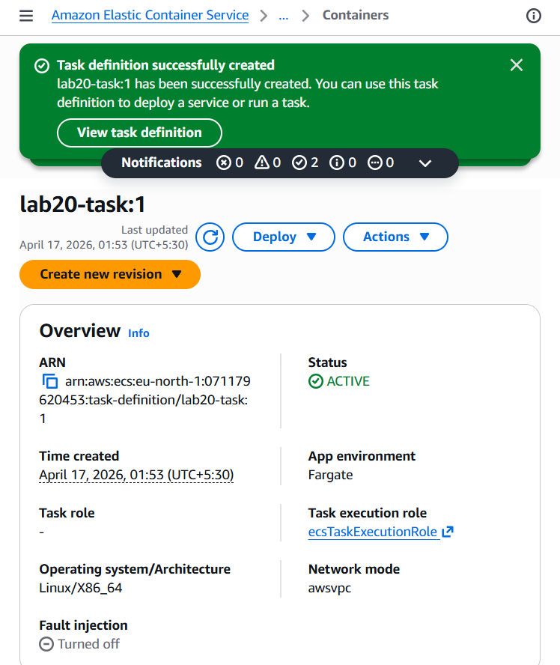

Step 6: Create an ECS Service
Deploy your task definition into the cluster.
- Navigate back to your lab20 cluster and go to the Services tab. Click Create.
- Under Compute configuration, select Launch type and ensure Fargate is chosen.
- Under Deployment configuration, set the Task definition family to lab20-task and select the latest revision.
- Assign a Service name, such as lab20-task-service-050smovw.
- Set the desired tasks to 1.
- Click Create to deploy the service. Wait a few minutes for the deployment to finish and the task status to turn to Running.

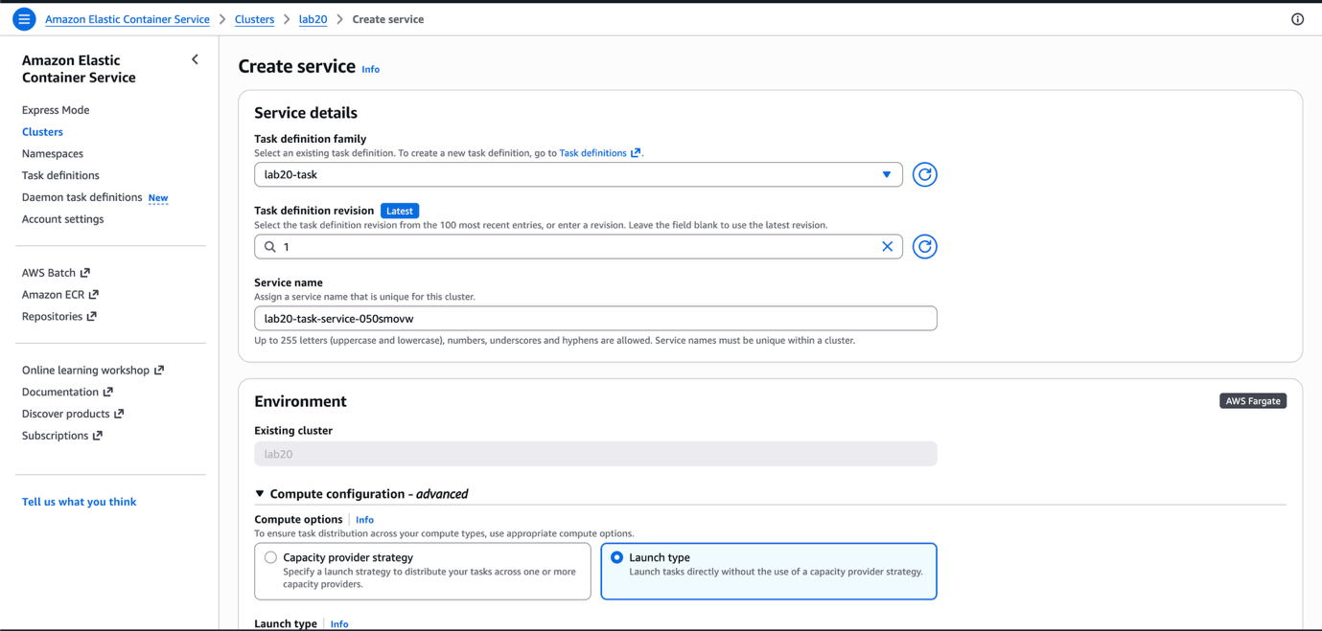
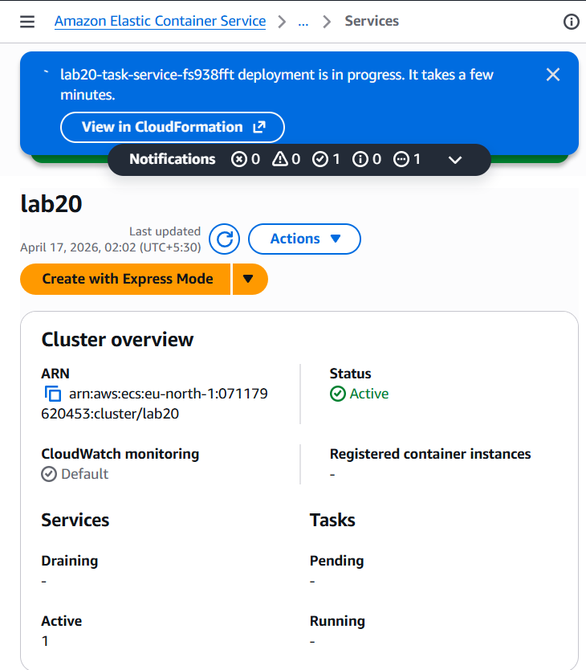

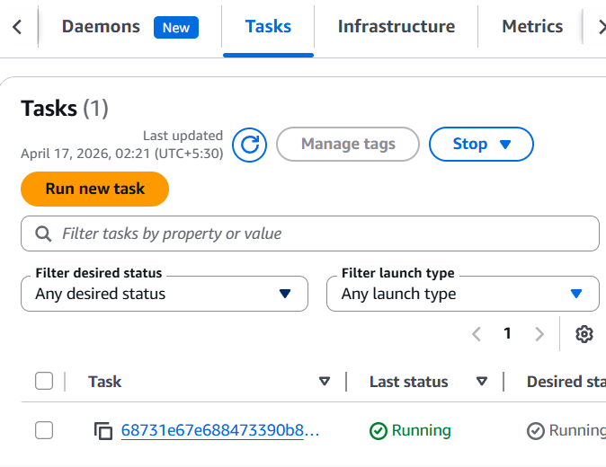

Step 7: Configure Security Groups
Ensure public traffic can reach your web server on port 80.
- Locate the Elastic Network Interface (ENI) or the Security Group associated with your running ECS Task.
- Open the VPC Dashboard or EC2 Security Groups console.
- Select the relevant security group (e.g., sg-0b5feb81b90a56a72 - default).
- Edit the Inbound rules.
- Add a rule to allow All traffic (or specifically HTTP) on Port 80 from the Source 0.0.0.0/0.
- Save the rules.
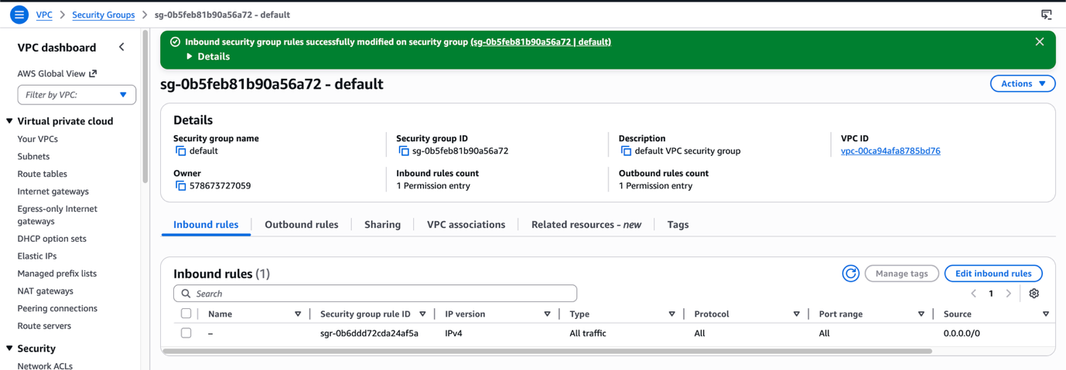

Step 8: Verify the Deployment
Access your live application over the internet.
- In the ECS console, navigate to your running task inside the lab20 cluster.
- Find the Public IP address assigned to the Fargate task
- Open a new tab in your web browser and navigate to (http://13.127.18.163).
- You should see the "Hello Everyone!" heading. Click the link to verify routing to the "About Us" page.
